**System Requirements Specification**

**< IT_Capstone 4905 >**

**< Budget Tracker System>**

**Team Member: Andrew Yang, Jian Ma**

**Sponsor: Diana Bergeman**

#### **Approval Signatures**

|  |  |  |
| --- | --- | --- |
| **Approved by: Business Project Leader** |  | **Approved by: IM/IT Project Leader** |
|  |  |  |
|  |  |  |
|  |  |  |
| **Prepared by: Business Project Manager** |  | **Prepared by: IM/IT Project Manager** |
|  |  |  |
|  |  |  |
|  |  |  |
|  |  | **Reviewed by: Quality Assurance Manager** |

This is the section for the control of the outline planning, which teammates or sponsors can edit and update this document. The editor should provide the date and the description of the changes, in order to maintain the development and distribution of revisions.

|  |  |  |  |
| --- | --- | --- | --- |
| **Revision Number** | **Date of Issue** | **Author(s)** | **Description of Change** |
|  |  |  |  |

**Table of Contents**

1. **Project Summary**
2. **Points of Contact**
3. **Introduction**
   1. **Purpose, Scope, and Objectives**
4. **Overall Description**
   1. **Functions**
   2. **Use cases**
   3. **Operating environment**
   4. **User Documentation**
   5. **Assumptions and Dependencies**
   6. **Project Constraints**
5. **External Interfaces**
   1. **User**
   2. **Hardware**
   3. **Software**
   4. **Communications**
6. **System Features (Functional requirements)**
7. **Non-Functional Requirements**
   1. **Performance**
   2. **Safety**
   3. **Security**
   4. **Quality**
   5. **Legal, Social**
   6. **Environmental**
   7. **Business Rules**
8. **Other Requirements**
9. **Project Summary**

Create a budget tracking system that allows users to log purchases, expenses, etc., pull up reports on any defined chart string and see pending charges, expended charges, and report to show % of the year that’s gone by, % of funds already spent, amount available to spend, etc.

1. **Points of Contact**

|  |  |  |
| --- | --- | --- |
| Role | Name | Email address |
| Team member | Andrew Yang | andrewyang@my.unt.edu |
| Team member | Jian Ma | jianma@my.unt.edu |
| Sponsor | Diana Bergeman | diana.bergeman@unt.edu |
|  | David Keathly | david.keathly@unt.edu |

1. **Introduction**

In order to analyze the budget of the College of Engineering in UNT, the sponsor needs to use Microsoft Excel to complete the task. However, there are hundreds of data needs to be processed, which makes it very complicated by using Excel. Hence, we decided to use Microsoft Access software to create a more efficient and easy method to help sponsor solve this problem.

* 1. Purpose, Scope, and Objectives
* Create a budget tracking system by using Microsoft Access.
* The product should have a variety of functions to fulfill sponsor’s requirements.

1. **Overall Description**
   1. Functions

* Allow the data entry
* Allow to create new indexes
* Has the ability to sort the data
* Running reports in any field with any or a combination of parameters identified
* calculate how much of total budget is spent
* calculate how much of my fiscal year has gone by
* System needs to be able to run based off of fiscal year time frames rather than giving me everything that ever existed
  1. Use cases

This budget tracking system is managed by the administrative coordinator of the department. Only one person needs to access this product. Therefore, this product can be local based instead of connecting to the internet.

* 1. Operating environment

This budget tracking system is based on Microsoft Access. Due to Access can only be run on Windows, users can only use this product on a Windows computer or a Mac computer which can access VMware fusion.

* 1. User Documentation

In order to show how to use the product we created, we will give a manual to the user. The manual will be given in a Word or PowerPoint document.

* 1. Assumptions and Dependencies

Due to both our team members’ laptops being under MacOS, we have to figure out how to access Windows on our laptop. This could be the biggest factor that will affect the requirements. And our software is locally based, so maybe only one of our team members can develop the software at the same time. Our product will be only performed using Microsoft Access, so we don’t need any other software components.

* 1. Project Constraints

The constraints for our product are that it is a local based software, so maybe it cannot access the internet for multiple users to use it at the same time. Also, users can only use this software under the Windows system.

1. **External Interfaces**
   1. User

Due to our product being based on Microsoft Access, we will have the user interface like this. And we will fully take advantage of the functions it has.

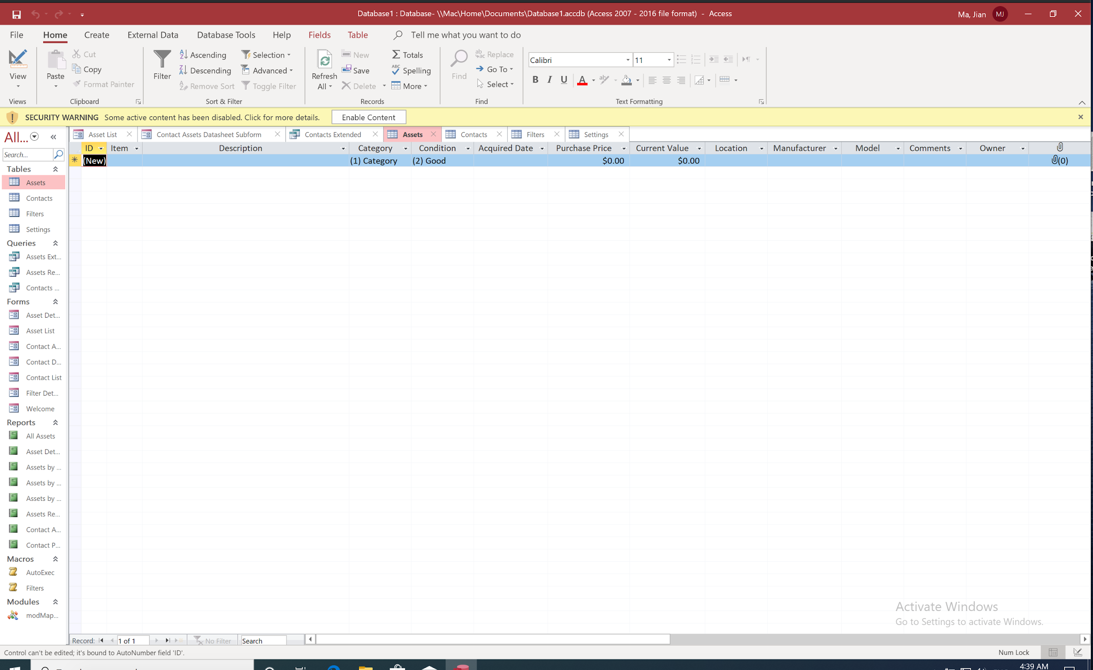

* 1. Hardware

In order to use our product, the user must have hardware which can access Windows systems. Also, users have to install Microsoft Access.

* 1. Software

Access is a software like a database management system. So, it will have some actions such as inserting data from Excel or exporting the data into an Excel document. The data in Access can be calculated using some formulas. In addition, we may create some queries to analyze the data under different requests.

* 1. Communications

There aren't any communication functions, such as e-mail, network protocol, HTTP, FTP, etc, needed to be created for our product. But we will try to develop some features such as databases or something upon sponsor’s requirements.

1. **System Features (Functional requirements)**
   1. Description

The system needs to be able to run based on fiscal year time frames rather than giving everything that ever existed. For this action, it needs to calculate how much of the total budget is spent and calculate how much of my fiscal year has gone by. The sorted data and analysis need to be searchable and easy to find.

* 1. Priority
* High: The user must be able to search the sorted data of the initial set of the database or select an analysis (maybe a graph or a chart) from it.
* Medium: The calculation of the budget (spent, fiscal year) must show the steps and point out where the data located.
* Low: System should provide an easier environment for the user to enter or delete the data, in order to do the next request step.
  1. Stimulus/Response Sequences

-Stimulus: User enter their budget

Response: The budget sort into the excel and display on the data sheet

-Stimulus: User click on the total budget spending

Response: system do the calculation of the budget spending and display the result and sort the result into a data sheet.

-Stimulus: User click on calculate fiscal year spending

Response: system do the calculation of the fiscal spending and display the result and sort the result into a data sheet.

-Stimulus: User click on show the result of a person (ex: A1)

Response: System displays the sorted data sheet, analysis graph of the A1 on the screen.

* 1. Functional Requirements

REQ-1: The user should be able to view and choose to click on any button in the Access.

REQ-2: The user should be able to enter the "number/digits" in the sheet.

REQ-3: The database should be able to call out the specific person's sorted data and analyzation.

1. **Non-Functional Requirements**
   1. Performance

PE-1: Responses to queries shall not take longer than three milliseconds.

PE-2: The system should display the sorted data and analysis not longer than 4 milliseconds after the user clicks the display button.

PE-3: The calculation and graphing of data should accuracy of 99% or more, based on the data are all numbers.

* 1. Safety

Privacy: This system is only used by the user who owns this system, therefore, the data should be saved only on the user's PC or the user's Microsoft account.

* 1. Security

SE-1: Only the owner/admin has access to any data generated by this system. The data will not share with others.

SE-2: Only used by the user who owns this system, which means it is a personal system, and has only one admin/user.

* 1. Quality

Availability-1: The system should be only available to one local user.

Availability-2: The system should always have an error message when the user enters the wrong thing.

Efficiency-1: The system should do the right calculation and generate a suitable graph or chart for the analysis.

Efficiency-2: The system should provide an easy environment to do the searching and entering.

* 1. Legal, Social

Only using Microsoft excel, access, MySQL, or any "Licensed software" to make this system.

* 1. Environmental

Provide an easier UI for the user, not just a page of thousands of data. Data should be sorted in different categories or divide into different pages.

* 1. Business Rules

Only used to analyze the budget of the College of Engineering in UNT. The product should only be used by the sponsor.

1. **Other Requirements**

All the requirements have been specified in this document.